Implementation Plan

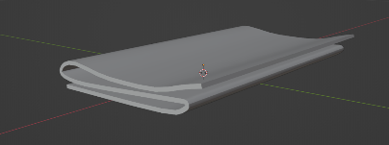**Displaying 3D Polygon Mesh:**

I plan to make all the models for this game myself in Blender. I have already made the following models: Bike, Basic Building Model, Newspaper, 3D map with driveways.

Other Models I plan to make for the project include a paperboy, a bigger map, hedges, other characters. I will save working on these other models until later in the project.

**Interactive Manipulation**

The actions and controls for the game will be the same as the original game with WASD used for steering the bike and Q and E used to throw the papers left and right.

So far, I have implemented steering, but not yet the throwing functionality. The plan is to spawn a newspaper and project it along a parabolic curve when the throw button is pressed.

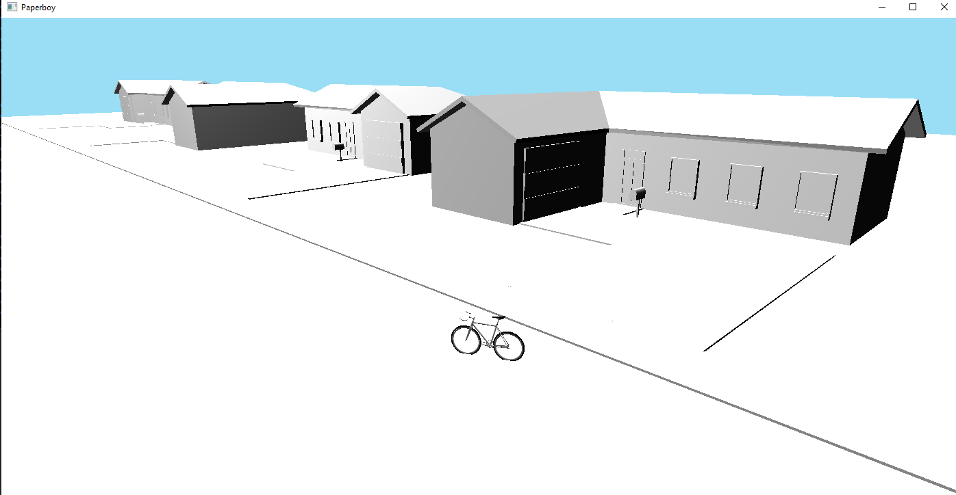

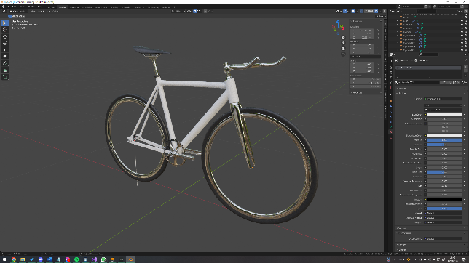

**Complex Object with a Hierarchical Structure**

To do this I have separated the models into their sub meshes and so that I can manipulate them separately relative to the model.

The complex object will be the bike which will have spinning wheels, pedals and a handlebar that turns as the bike turns. (These are all only one deep hierarchies, is that adequate?)

**The Scene must be Lit and Shaded, including diffuse and specular objects**

The plan is to create a shader in which the diffuse, specular can be adjusted.

I will keep the buildings with a low specular value, so they appear rough, and I’ll increase the specularity of the road so a reflection of the sun light can be seen.

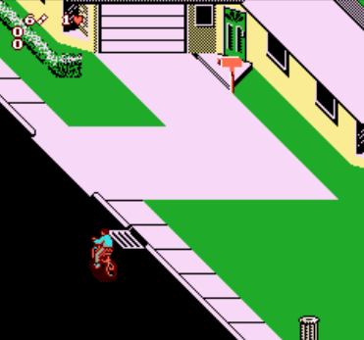**2 Camera Viewpoints**

At the moment I have a camera that can fly around the scene.

The plan is to set up two other cameras that can be toggled between. One shall be an isometric view similar to that in the original game. The other viewpoint will be from a wide third person perspective, that transforms relative to the bike.